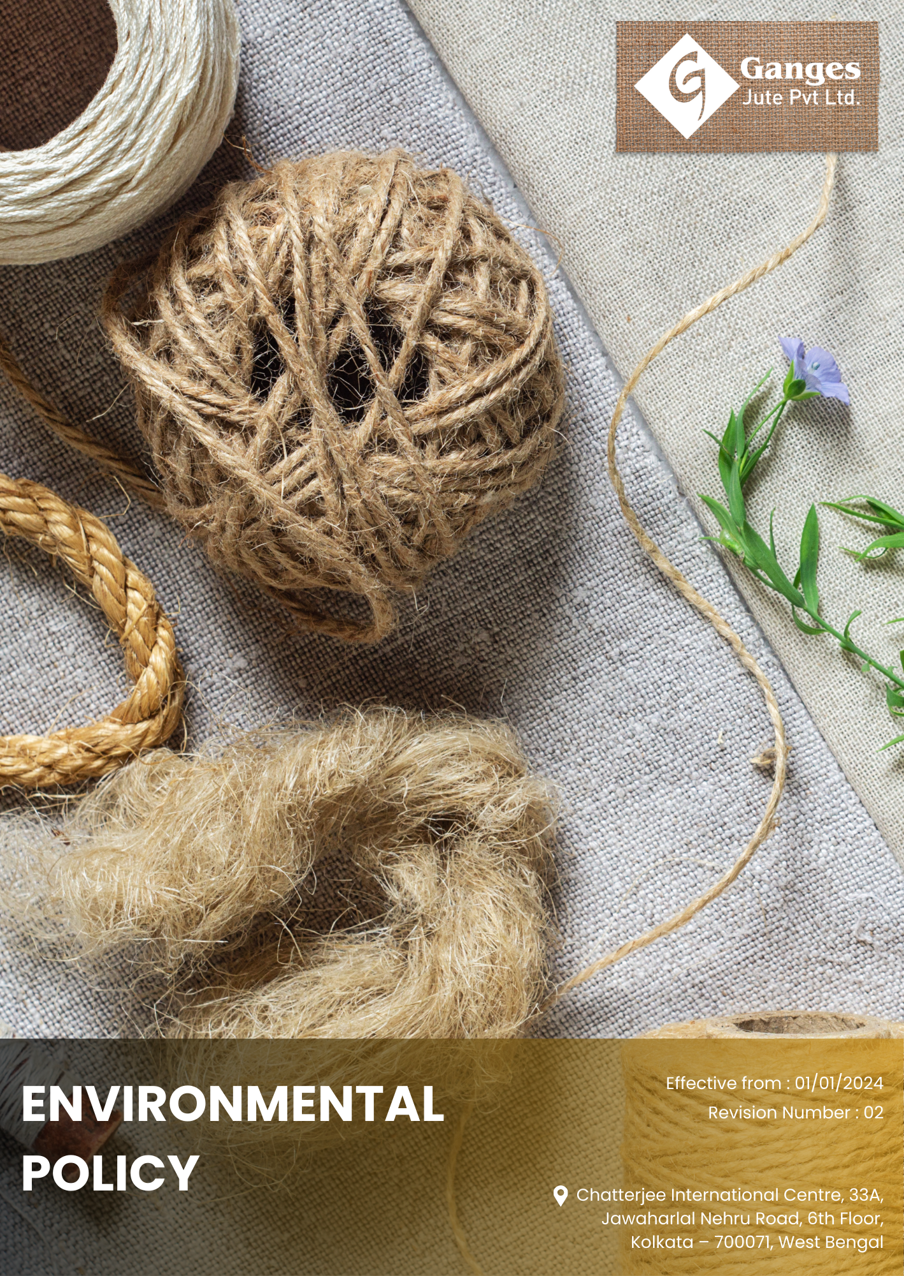

Table Of Contents

1. Why It Matters 3
2. The Ganges Jute Way 3
3. Scope 3
4. What's Expected 3
5. Jute's Journey to Sustainability: A Ganges Jute Commitment 4
6. Responsibility 7
7. Reporting Section 8
8. Covered SDGs 9
9. Review Mechanism 9
10. Employee Acknowledgement Form: Environmental Policy 11

Why It Matters
Ganges Jute Pvt Ltd is committed to protecting the environment, promoting sustainable jute cultivation and processing, and extending our eco-friendly mindset across the entire supply chain. This commitment is not only an important social responsibility but also creates value for our business, customers, stakeholders, and employees.

The Ganges Jute Way
It is the policy of Ganges Jute Pvt Ltd to design, manufacture, and deliver our jute products and to operate our business in a way that protects the environment and promotes the sustainable use of natural resources. This includes responsible jute farming, water conservation, efficient use of raw materials, and clean energy utilization, while extending our eco-friendly mindset across the value chain.

We set Annually goals, develop necessary capabilities, and commit appropriate resources to achieve this policy through innovation, operational efficiency, and aligning Ganges Jute's supply chain with this policy.

Scope
This policy applies to all employees, stakeholders, contractors, partners, customers, contractual workers, and anyone acting on behalf of following sites:

 | Ganges Jute Pvt Ltd
 | Address: Bansberia, Hooghly District, West Bengal, India
 | https://gangesjute.com/

What's Expected
- Environmental Compliance
Ganges Jute Pvt Ltd complies with all applicable environmental laws and regulations. We also foster employee engagement, set performance standards, and utilize an Environmental Management System to drive compliance and continuous improvement, including through:
- Implementing water usage reduction and recycling measures in all operations;
- Adopting renewable energy sources and implementing energy efficiency measures to reduce our carbon footprint;
- Setting and achieving greenhouse gas (GHG) reduction targets through various sustainability initiatives;
- Minimizing waste generation and promoting recycling throughout our operations and supply chain;
- Supporting biodiversity through sustainable jute cultivation practices and conservation efforts;
- Implementing robust procedures to manage local and unexpected contamination effectively;
- Reducing air pollution by adopting advanced processing technologies and emissions control measures;
- Minimizing noise pollution through the use of soundproofing technologies and maintaining operational standards;
- Managing raw materials and chemicals responsibly, including the use of eco-friendly dyes and chemicals;
- Developing products that have minimal environmental impact during their use phase;
- Creating biodegradable and compostable products to reduce environmental impact at the end of their lifecycle;
- Ensuring customer health and safety by adhering to stringent quality control and safety standards;
- Promoting sustainable consumption by advocating for jute as an environmentally friendly alternative to synthetic materials;

Jute's Journey to Sustainability: A Ganges Jute Commitment:
- Establishes 2022 as the Baseline year for measuring progress and achievements in our sustainability initiatives.

- Water usage reduction and recycling:
- We aim to achieve a 10% reduction in water consumption and 60% water recycling by 2030, through the implementation of a closed-loop water recycling system and advanced membrane filtration technology.
- We plan to optimize our jute retting process, reducing water consumption by 10% through the adoption of ribbon retting technology by 2030.
- We intend to implement a rainwater harvesting system, meeting 25% of our water needs from this sustainable source by 2030.

- Renewable energy and energy efficiency:
- We aim to attain 40% renewable energy usage and improve energy efficiency by 25% by 2030, through the installation of rooftop solar panels and upgrading to energy-efficient machinery with smart power management systems.
- We plan to transition 100% of our process heating to biomass-based systems, utilizing jute waste as fuel by 2030.
- We intend to achieve a 25% reduction in energy consumption for jute processing by implementing variable frequency drives and energy-efficient motors across all production lines by 2030.
- Greenhouse gas (GHG) reduction:
- We aim to reduce Scope 1 and 2 GHG emissions by 15% by 2030, by switching to electric vehicles for internal transportation and optimizing production processes using AI-driven energy management software.
- We plan to reduce our Scope 3 emissions by 15% by 2030, through optimized logistics and the implementation of a supplier engagement program focused on emissions reduction.
- We intend to achieve carbon neutrality for our administrative operations by 2030, through a combination of emissions reduction initiatives and investment in verified carbon offset projects.

- Waste minimization and recycling:
- We aim to achieve 40% waste recycling and reduce total waste generation by 15% by 2030, through the implementation of a comprehensive waste segregation system and developing innovative applications for jute waste in packaging and construction materials.
- We plan to develop a closed-loop manufacturing system, reintegrating 45% of jute processing waste back into our production cycle by 2030.
- We intend to reduce packaging waste by 30% by 2030, through the implementation of reusable packaging solutions and biodegradable alternatives.

- Biodiversity support:
- We aim to increase sustainable jute cultivation area by 30% and establish 5 biodiversity conservation projects by 2027, by partnering with local farmers to promote sustainable farming practices and creating wildlife corridors in collaboration with environmental NGOs.
- We plan to establish a seed bank preserving 100 native jute varieties by 2030, supporting genetic diversity and resilience in jute cultivation.
- We intend to implement agroforestry practices on 20% of our contracted farming land, enhancing biodiversity and providing additional income streams for farmers by 2030.

- Contamination management:
- We aim to implement real-time monitoring systems for 100% of potential contamination sources and reduce incidents by 80% by 2030, through the installation of IoT sensors for early detection and the development of a rapid response protocol.
- We plan to achieve zero soil contamination incidents by 2030, through the implementation of advanced containment systems.
- We intend to reduce chemical spills by 95% by 2030, through the adoption of automated dosing systems and staff training in best practices for chemical handling.

- Air pollution reduction:
- We aim to reduce particulate matter emissions by 30% and volatile organic compounds (VOCs) by 40% by 2030, , through the installation of advanced electrostatic precipitators and switching to water-based, low-VOC processing chemicals.
- We plan to eliminate all ozone-depleting substances from our operations by 2030, , through the adoption of natural refrigerants and eco-friendly cleaning processes.
- We intend to reduce odor emissions by 60% by 2030, , through the installation of bio-filtration systems and the optimization of our waste treatment processes.

- Noise pollution minimization:
- We aim to reduce average noise levels by 15 dB and implement noise barriers for 100% of high-noise areas by 2030, by installing sound-absorbing materials and redesigning our facility layout based on acoustic modelling software recommendations.
- We plan to achieve a 50% reduction in noise-related complaints from neighbouring communities by 2030, through strategic equipment placement and the creation of green buffer zones.
- We intend to implement a noise mapping and monitoring system, allowing real-time adjustments to maintain noise levels below 60 dB at our facility boundaries by 2030.

- Responsible raw material and chemical management:
- We aim to achieve 100% use of eco-friendly dyes and chemicals and increase sustainable raw material sourcing by 75% by 2030, through partnerships with certified eco-friendly suppliers and the development of in-house sustainable alternatives using green chemistry principles.
- We plan to transition to 100% organic jute sourcing for our premium product line by 2030, working closely with farmers to support their transition to organic cultivation.
- We intend to develop a proprietary eco-friendly jute softener, reducing chemical usage by 50% in our softening process by 2030.

- Environmentally friendly product development:
- We aim to develop 5 new eco-friendly jute products with 50% lower environmental impact by 2030, by investing in R&D for innovative jute applications and conducting comprehensive lifecycle assessments using specialized LCA software.
- We plan to launch a range of jute-based biodegradable alternatives to single-use plastics, capturing 5% of the eco-friendly packaging market by 2030.
- We intend to develop jute-based construction materials with 20% lower carbon footprint compared to conventional materials, to be introduced to the market by 2030.

- Biodegradable and compostable products:
- We aim to ensure 60% of our product range is fully biodegradable or compostable by 2030, by developing new finishing techniques that maintain product quality while ensuring biodegradability, verified through accelerated biodegradation testing.
- We plan to establish a take-back program for our products, ensuring proper end-of-life composting and achieving a 20% return rate by 2030.

- Customer health and safety:
- We aim to achieve zero product recalls and 100% compliance with international safety standards by 2030, through the implementation of AI-powered quality control systems and enhanced traceability using blockchain technology.
- We plan to implement a real-time traceability system allowing customers to track the entire lifecycle of their jute products from farm to shelf by 2030.

- Promoting sustainable consumption:
- We aim to increase market share of jute products by 30% and educate 1 million consumers on jute benefits by 2030, through the launch of targeted digital marketing campaigns and collaborations with eco-conscious retailers, leveraging social media analytics for maximum impact.
- We plan to establish partnerships with 30 major retailers to create dedicated "Sustainable Jute" sections in their stores by 2030, increasing visibility and accessibility of jute products.
- We intend to launch a consumer education app providing information on the environmental benefits of jute and proper product care, reaching 1 million active users by 2030.

- Green-path Advocacy
- We empower our suppliers and customers by providing training and resources to effectively utilize advanced technologies such as smart meters, energy management systems (EMS), IoT sensors, and waste tracking software. We aim to drive significant reductions in energy consumption, water usage, greenhouse gas emissions, and waste generation, with a target to achieve these goals by 2030 . Through this initiative, we plan to enhance overall sustainability and foster a culture of environmental stewardship across our supply chain and customer base.

Responsibility
- Board of Directors:
- Oversees the overall environmental strategy and approves long-term sustainability goals.
- Ensures alignment of environmental initiatives with business objectives and stakeholder expectations.

- Chief Sustainability Officer (CSO):
- Leads the development and implementation of the Environmental policy across the organization.
- Reports directly to the CEO and provides regular updates to the Board of Directors.

- Senior Management:
- Provides leadership in implementing the Environmental policy within their respective divisions.
- Allocates necessary resources and integrates sustainability metrics into performance evaluations.

- Sustainability Committee:
- A dedicated sustainability committee comprising representatives from various departments is established to oversee the execution of sustainability initiatives.
- The committee is tasked with developing action plans, monitoring performance, and recommending improvements to meet sustainability objectives.

- Departmental Heads:
- Departmental heads are responsible for integrating sustainability practices into their respective areas of operation.
- They ensure compliance with environmental regulations, promote resource efficiency, and support employee engagement in sustainability efforts.

- Environmental Compliance Manager:
- Ensures adherence to all applicable environmental laws, regulations, and standards.
- Conducts regular audits and maintains documentation for regulatory compliance

- Employees:
- All employees are encouraged to actively participate in sustainability initiatives.
- They are expected to adhere to sustainable practices, report any environmental concerns, and contribute ideas for continuous improvement.

Reporting Section
- Internal Reporting:
- Annual Sustainability Dashboard:
- The CSO presents a comprehensive sustainability dashboard to senior management and the Board.
- The dashboard highlights progress towards annual targets, emerging trends, and areas needing attention.
- Environmental Incident Reporting:
- A dedicated system for employees to report environmental incidents or near-misses.
- The Environmental Compliance Manager investigates all reports and implements corrective actions.

- External Reporting:
- External reporting is conducted annually to communicate our sustainability performance to stakeholders, including customers, investors, and regulatory bodies.
- Reports are prepared in accordance with internationally recognized standards such as the Global Reporting Initiative (GRI) guidelines or Sustainability Accounting Standards Board (SASB) framework.

- Stakeholder Engagement:
- We actively engage with stakeholders to gather feedback, address concerns, and foster transparency in our sustainability practices.
- Stakeholder input is considered in decision-making processes and incorporated into sustainability initiatives where applicable.

Covered SDGs
 | 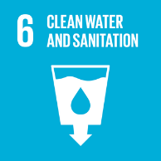 | 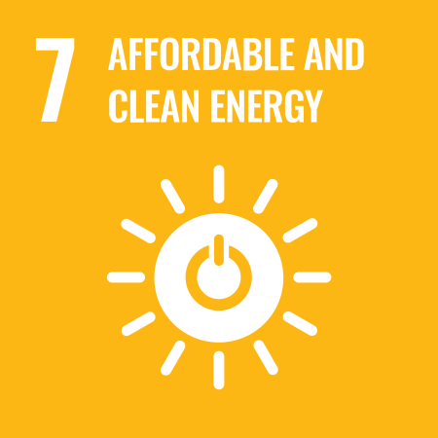 | 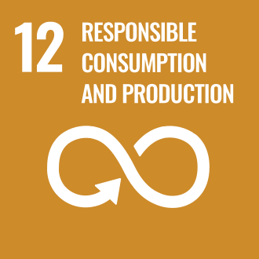 | 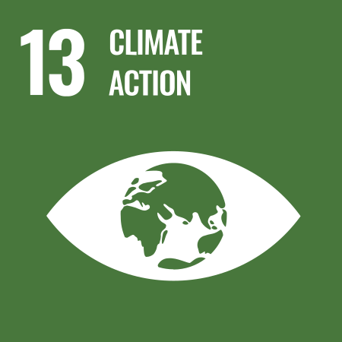 | 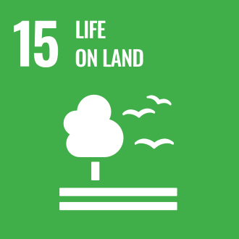

Review Mechanism
- Annual Performance Review:
- An annual performance review is conducted to assess progress towards sustainability goals and targets.
- Key achievements, challenges, and areas for improvement are identified through a comprehensive evaluation process.

- Continuous Improvement:
- Feedback from performance reviews, internal audits, and stakeholder engagement activities is used to identify opportunities for continuous improvement.
- Adjustments to strategies, policies, and action plans are made as necessary to enhance sustainability performance and address emerging issues.

- Policy Review and Update:
- The Chief Sustainability Officer reviews this policy Every two years to ensure alignment with changing regulatory requirements, industry best practices, and stakeholder expectations.
- Updates to the policy are communicated internally, and relevant training is provided to ensure awareness and compliance.

- Revision History

Revision No. | Revision Date | Description of Change
01 | 01-01-2024 | Initial release of the Environmental Policy
02 | 01-01-2025 | Modified sustainability targets with revised achievement timelines and added a formal Revision History table

(Signature)
Approved By: Mr. Ashwini Kariwala
Designations: Executive Director
Last Review Date: 01-01-2025 Next Review Date: 01-01-2027

Employee Acknowledgement Form: Environmental Policy

I, acknowledge that I have received, read, and understood Ganges Jute Pvt Ltd's Environmental Policy. I am aware of the company's commitment to protecting the environment, promoting sustainable jute cultivation and processing, and extending our eco-friendly mindset across the entire supply chain.
I understand my role in supporting this policy, including complying with all applicable environmental laws and regulations, participating in sustainability initiatives, and contributing to the company's environmental goals. I agree to adhere to sustainable practices in my daily work, report any environmental concerns, and contribute ideas for continuous improvement.
By signing below, I confirm my commitment to upholding Ganges Jute Pvt Ltd's Environmental Policy and supporting the company's sustainability efforts.

Employee Name: ______________________
Date: _______________
Employee Signature: ____________________

